RDS PostgreSQL Connection Management, Spike Handling & Optimization using RDS Proxy

1. Project Title
End-to-End Database Connection Optimization using Amazon RDS PostgreSQL / Aurora PostgreSQL, Parameter Groups, CloudWatch, RDS Proxy, and AWS Lambda

2. Objective
The objective of this POC is to design and implement a fully automated database connection management solution in AWS that:
- Creates and configures Amazon RDS PostgreSQL / Aurora PostgreSQL database
- Manages idle database connections automatically
- Detects and handles connection spikes
- Prevents database overload and crashes
- Optimizes connection usage using RDS Proxy
- Implements automated cleanup using AWS Lambda
- Ensures high availability and scalability.

3. Business Requirement
Modern applications face critical database challenges such as:
- Sudden spike in database connections
- Idle connections consuming resources
- Risk of exceeding maximum database connections
- Database performance degradation under load
- Need for automated connection management without application changes

4. End-to-End Solution Overview
The solution is built using AWS managed services:
- Amazon RDS PostgreSQL / Aurora PostgreSQL (Database layer)
- DB Parameter Group (Idle session control)
- CloudWatch Alarm (Monitoring & spike detection)
- RDS Proxy (Connection pooling & protection layer)
- AWS Lambda (Automated idle connection termination.

Implementation Steps (End-to-End)

5). Create PostgreSQL RDS Database
AWS Console Path:
RDS → Create database

Configuration:
Setting | Value
Engine | PostgreSQL / Aurora PostgreSQL
Version | 17.
Deployment | Production / Dev (as per need)
DB Instance | db.t3. medium
Storage | GP3
VPC | Prasad VPC
Public Access | Recommended
Security Group | Allow port 5432

Outcome:
✔ PostgreSQL database created successfully
✔ Endpoint generated for connection
Please find the below snippet for reference:
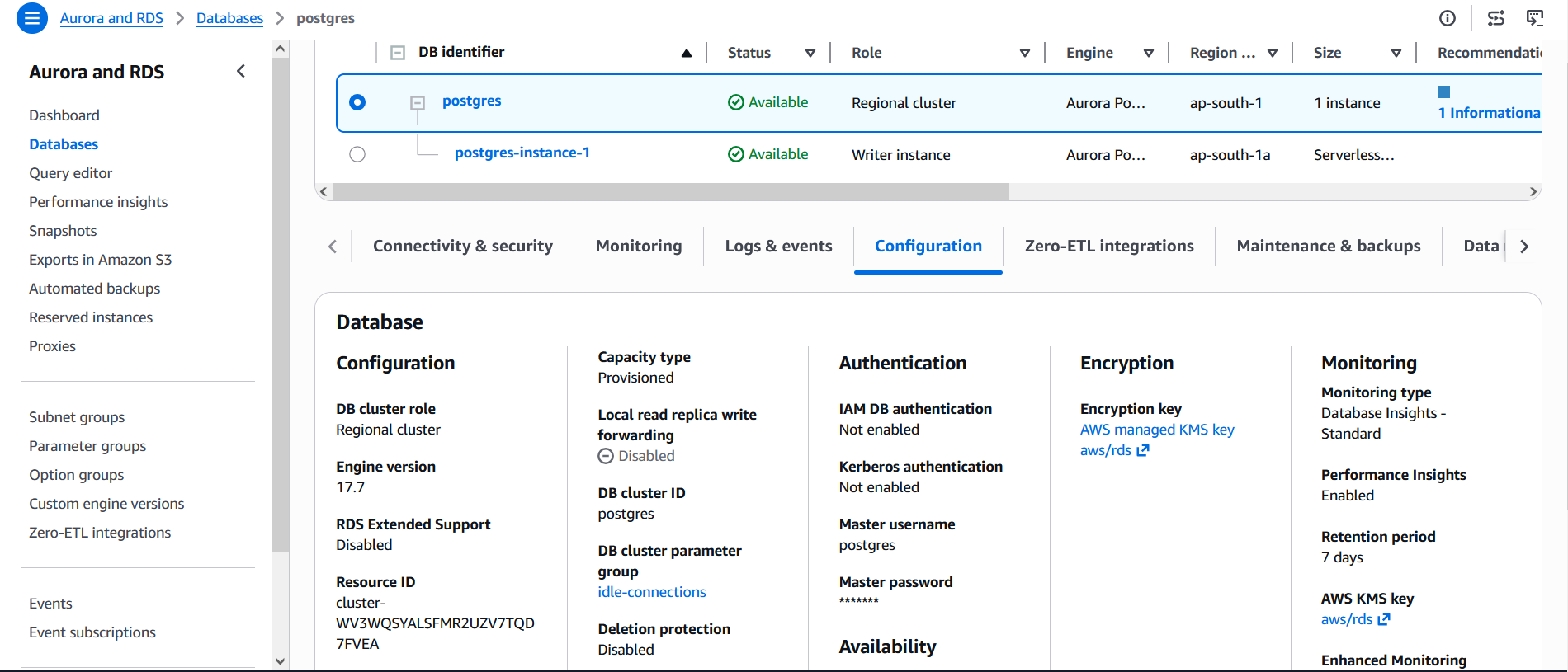

6). Create DB Parameter Group
AWS Console Path:
RDS → Parameter Groups → Create Parameter Group

Configuration:
- Name: idle connections
- Engine: PostgreSQL / Aurora PostgreSQL

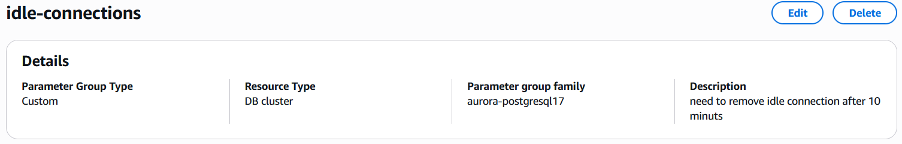

Modify Parameters:
Parameter | Value | Purpose
idle_session_timeout | 600000 ms | Terminates idle sessions
idle_in_transaction_session_timeout | 600000 ms | Terminates idle transactions
statement_timeout | 1800000 ms | Prevent long queries

Apply:
Modify RDS Cluster → Attach Parameter Group → Apply Immediately

7). Verify Database Configuration
Run SQL queries:
SHOW idle_session_timeout;
SHOW idle_in_transaction_session_timeout;
SHOW statement_timeout;
Expected Output:
- 600000 ms
- 600000 ms
- 1800000 ms

7.1). Monitor Active Connections
SELECT
pid,
usename,
backend_type,
application_name,
state,
now() - state_change AS idle_time
FROM pg_stat_activity
WHERE state = 'idle'
ORDER BY idle_time DESC;

Purpose:
- Identify idle sessions
- Monitor connection usage
- Validate timeout behaviour

8) Create CloudWatch Alarm
AWS Console Path:
CloudWatch → Alarms → Create Alarm

Configuration:

Setting | Value
Metric | DatabaseConnections
Namespace | AWS/RDS
Threshold | ≥ 100 connections
Period | 1 minute
Statistic | Average
Action | Alarm Enabled
Please find the implementation snippet below: 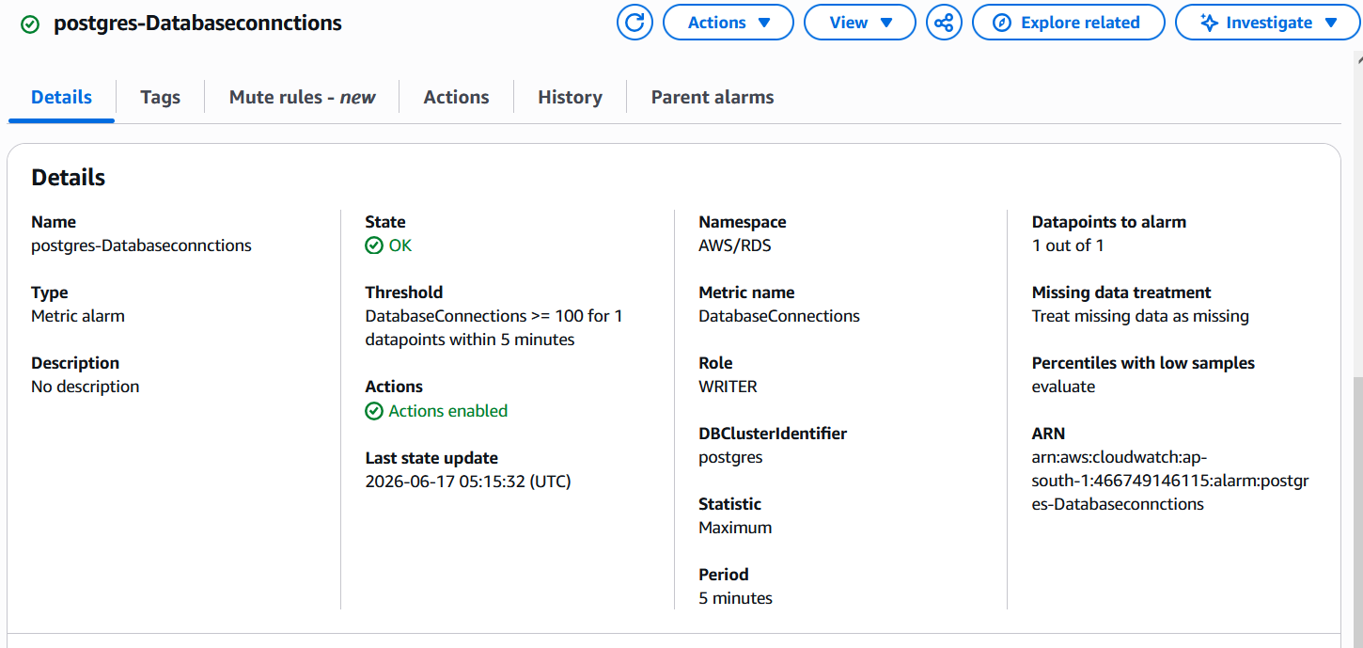
Purpose:
✔ Detect connection spikes
✔ Monitor database load in real-time
✔ Trigger alert for automation

9) Create RDS Proxy
AWS Console Path:
RDS → Proxies → Create Proxy

Configuration:
Setting | Value
Proxy Name | postgres-proxy
Engine | PostgreSQL
Idle Client Timeout | 30 minutes
Authentication | AWS Secrets Manager
IAM Role | rds-proxy-role
Target DB | PostgreSQL RDS Cluster

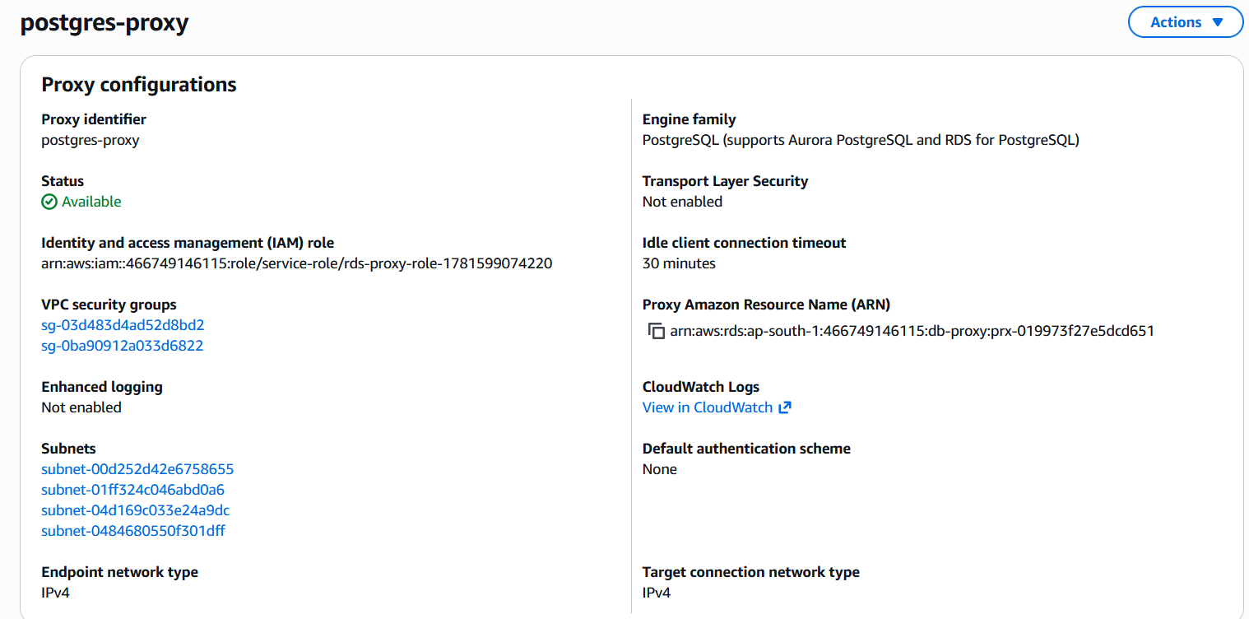
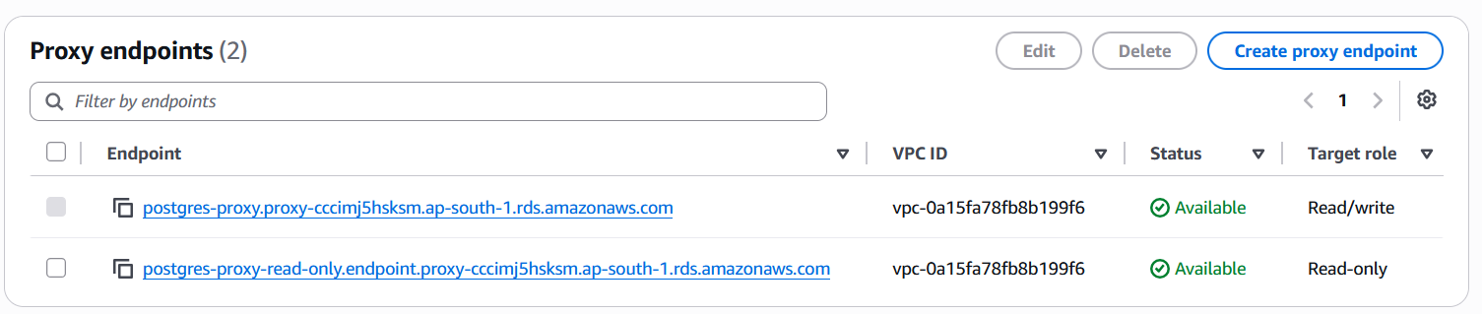

9.1) What exactly does RDS Proxy do
Connection Pooling
- Reuses existing database connections.
- Reduces connection creation overhead.
Connection Multiplexing
- Thousands of application connections can share a smaller pool of database connections.
Protection Against Connection Storms
- If a sudden spike occurs (e.g., 500 → 5000 connections), Proxy absorbs much of the load.
Faster Failover
- During multi-AZ failover, applications reconnect through Proxy endpoint instead of reconnecting directly to the database.
Reduced CPU and Memory Usage
- PostgreSQL processes each connection.
- Fewer backend connections = lower memory consumption.

10. AWS Lambda – Idle Connection Terminator
Purpose
Automatically terminates idle PostgreSQL sessions older than 10 minutes.

10.1 Why Lambda is Required
Even with RDS features:
- idle_session_timeout
- RDS Proxy pooling
We still need Lambda because:
- Some sessions remain unmanaged
- Application-specific idle sessions persist
- Custom business cleanup logic required
- Better control over connection lifecycle

10.2 Important RDS Limitation
⚠️ In RDS PostgreSQL / Aurora PostgreSQL:
- postgres user is NOT a true SUPERUSER
- It has rds_superuser privileges only
- AWS blocks termination of system sessions
- rdsadmin and internal processes cannot be killed

10.3 Lambda Configuration
- Runtime: Python 3.12
- VPC: Same as RDS Proxy
- Subnets: Private subnets
- Security Group: Same as RDS Proxy
- Layer: psycopg2 compatible layer

The created AWS Lambda layer configuration snippet is provided below for reference.
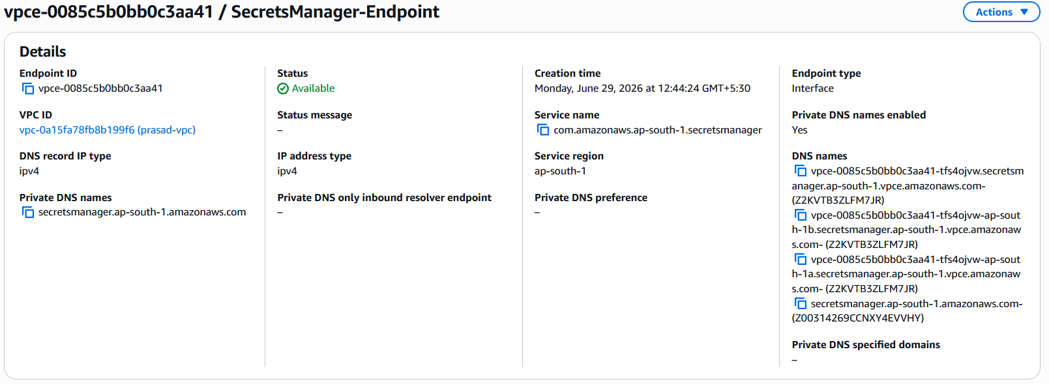

The successfully tested Lambda function snippet is provided below for reference.
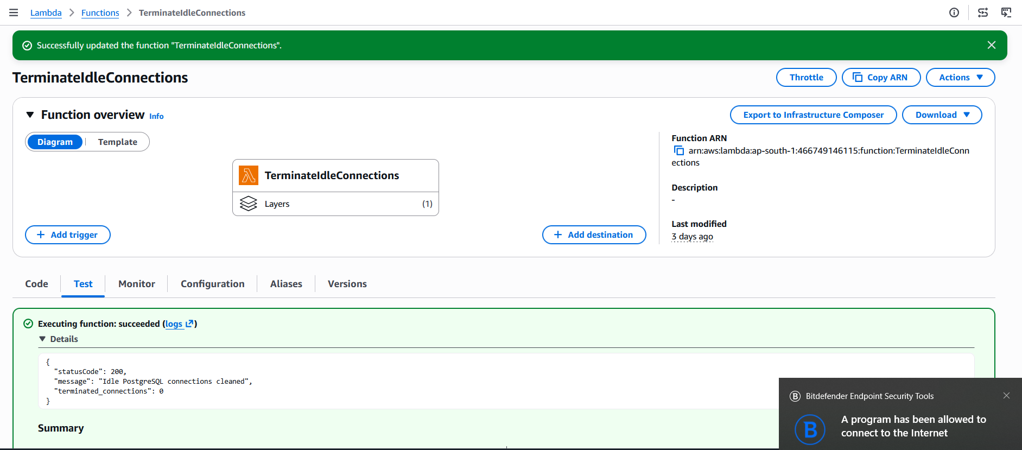

The created AWS Lambda layer configuration snippet is provided below for reference.
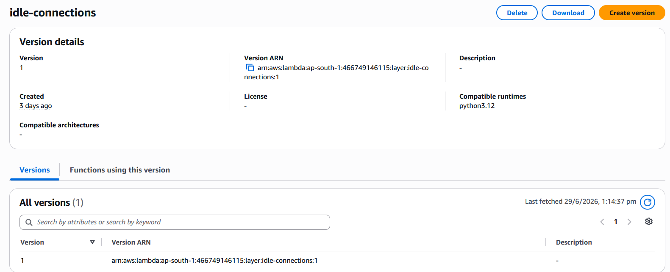

10.4 Lambda Code Implementation mentioned below:

import boto3
import json
import psycopg2
from datetime import datetime

RDS_PROXY_ENDPOINT = "postgres-proxy.proxy-cccimj5hsksm.ap-south-1.rds.amazonaws.com"
DB_PORT = 5432
DB_NAME = "postgres"
SECRET_NAME = "postgres-secret"

def get_secret():
client = boto3.client("secretsmanager")
response = client.get_secret_value(SecretId=SECRET_NAME)
return json.loads(response["SecretString"])

def lambda_handler(event, context):

connection = None
cursor = None

try:
print("Idle connection cleanup started:", datetime.now())

secret = get_secret()

connection = psycopg2.connect(
host=RDS_PROXY_ENDPOINT,
port=DB_PORT,
database=DB_NAME,
user=secret["username"],
password=secret["password"],
connect_timeout=10
)

cursor = connection.cursor()

query = """
SELECT pg_terminate_backend(pid)
FROM pg_stat_activity
WHERE state = 'idle'
AND now() - state_change > interval '10 minutes'
AND pid <> pg_backend_pid()
AND backend_type = 'client backend'
AND usename NOT IN ('rdsadmin', 'rdsproxyadmin');
"""

cursor.execute(query)

terminated = cursor.fetchall()

connection.commit()

count = sum(1 for row in terminated if row[0])

print("Idle connections terminated:", count)

return {
"statusCode": 200,
"message": "Idle PostgreSQL connections cleaned",
"terminated_connections": count
}

except Exception as e:
print("Error:", str(e))
return {
"statusCode": 500,
"error": str(e)
}

finally:
if cursor:
cursor.close()
if connection:
connection.close()

print("Database connection closed")

11. Working Architecture Flow

11.1 Normal Flow
Application → RDS Proxy → PostgreSQL RDS
✔ Connection pooling handled by proxy
✔ Reduced DB load

11.2 Spike Handling Flow
CloudWatch Alarm → Detect spike → RDS Proxy absorbs load → DB protected
✔ Prevents DB crash
✔ Handles traffic surge

11.3 Idle Connection Handling
Parameter Group + Lambda → Detect idle sessions → Terminate safely
✔ Frees unused connections

12. Results Achieved
- Idle connections automatically terminated after 10 minutes
- Database connections efficiently reused via RDS Proxy
- Connection spikes successfully controlled
- Database stability improved significantly
- No risk of connection exhaustion
- Improved performance under high load

12.1 Benefits
✔ Prevents database crash under load
✔ Handles connection spikes efficiently
✔ Optimizes database resource usage
✔ Reduces idle connection overhead
✔ Improves scalability and stability
✔ No application code changes required

Conclusion
This POC demonstrates a complete AWS-native solution for PostgreSQL connection management using:
- Amazon RDS / Aurora PostgreSQL
- DB Parameter Groups
- CloudWatch Monitoring
- RDS Proxy
- AWS Lambda Automation
The architecture ensures high availability, scalability, and stable database performance even during peak workloads.

*****************************************

